Quiz 2 ***(CSE331L.7 – Asif Ahmed Neloy_Summer’20)***

Department of Electrical and Computer Engineering

School of Engineering and Physical Sciences

North South University, Bashundhara, Dhaka-1229, Bangladesh

*Time 20 minutes, Marks 20 (You need to answer all questions).*

***Name - Md Tanvir Hossain***

***ID – 1521797642 0/10***

* **Write a program in Assembly language that will adds the even index values from an Array of Size 20.**

**Ans:**

**; You may customize this and other start-up templates;**

**; The location of this template is c:\emu8086\inc\0_com_template.txt**

**org 100h**

**arr db 20 dup(?)**

**ret**

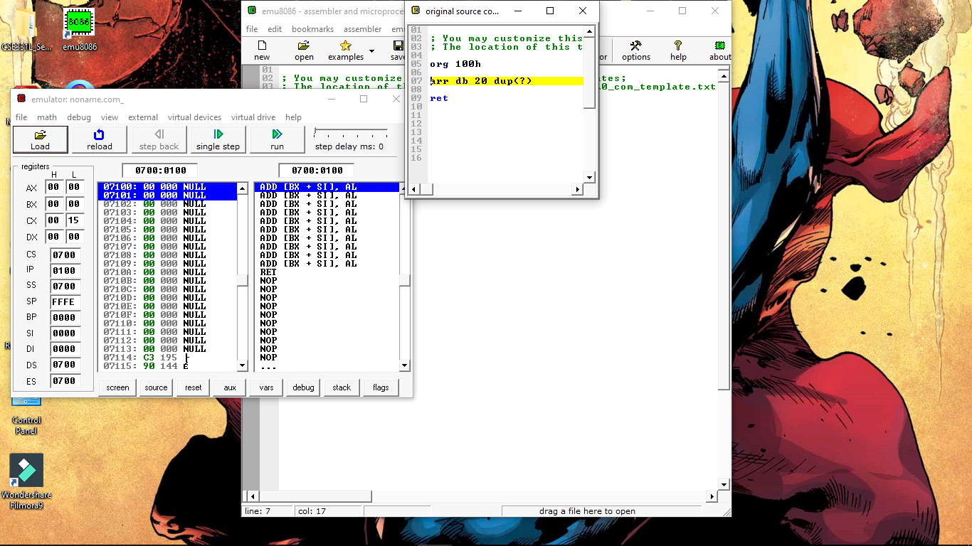

**End**